Lecture #15
13 November 2018
Copyright: Ronald B. Mitchell, 2018

Brown Weiss and Jacobson: Influences on treaty effectiveness

Overall model linking 4 sets of factors

Characteristics of activity: same as my “Problem structure”

Number of actors involved in activity

Effect of economic incentives

Role of multinational corporations in activity

Concentration of activity in major countries

Characteristics of institution: same as my “Institutional design”

Perceived equity of obligations

Precision of obligations

Provisions for obtaining scientific advice

Reporting requirements

Provisions for other forms of monitoring

Secretariat

Incentives

Sanctions

Characteristics of international context (see readings)

Characteristics of the country: why treaty influences some countries and not others (see readings)

Problem Structure and Institutional Effectiveness
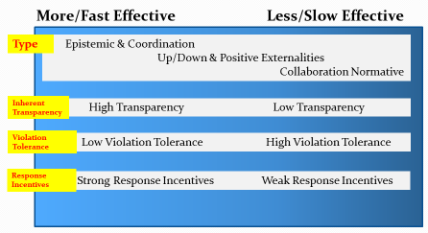

Institutional Design and Institutional Effectiveness
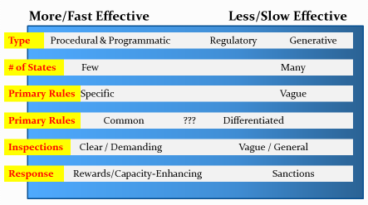

Successes & Failures of International Cooperation through Institutions

Successes of international cooperation through institutions

End of Polio, smallpox, decrease in malaria (300m/yr to 120m/yr)

1911 Fur Seal treaty

Steep declines in US/Soviet-Russian nuclear weapons

Destruction of (most of) Syria’s chemical weapons

Treaty of Versailles: debt of ~50K tons of gold over 59 years; final payment in 2010

Failures of international cooperation through institutions

League of Nations

Paris Peace Treaties of 1947: Italy, Romania, Hungary, Bulgaria, Finland sovereign states PLUS war reparations, minority rights and territorial adjustments

US-China trade war (WTO rules did not prevent)

Failure of international institutions to form in first place

US Navy ships near Spratly Islands

Palestinian-Israeli conflict

Brief example: have international institutions influenced number of nuclear weapons US and Soviets/Russia have?

The US had 25,000 nuclear weapons in 1960.

How many do you think the US has today?
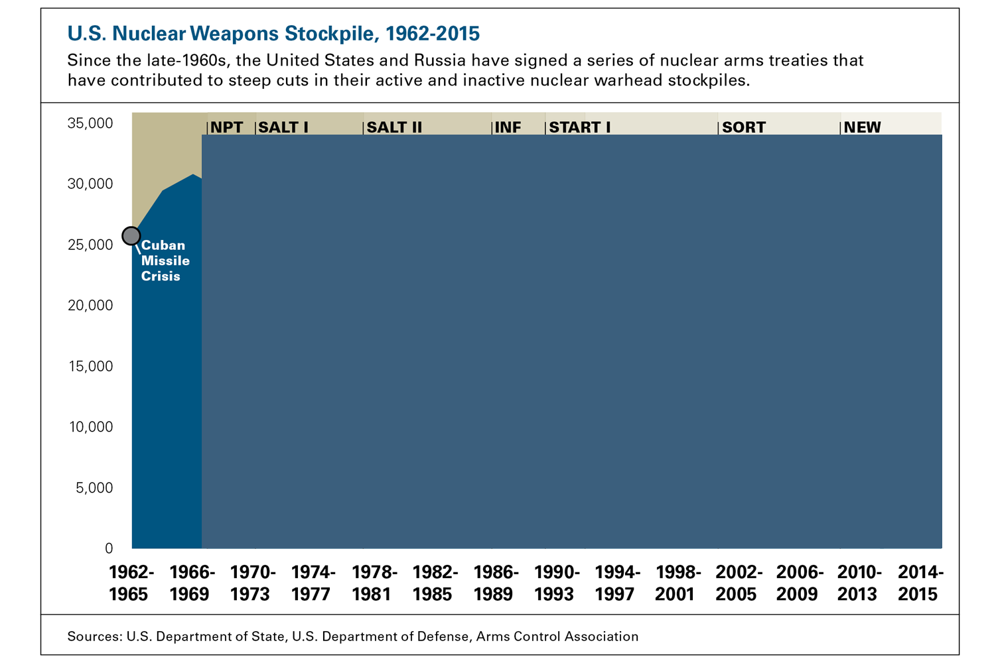

Example: Syria – have international institutions made a difference?

On the pro side:

Chemical Weapons Treaty in 1992, 165 countries signed

Creates pressure on others to respond as they said they would, with inspectors (Alex Bryans)

Strengthens a general norm: “international organizations can have an impact on how a country acts according to rules shared amongst most of the world” (Alex Bryans)

“Syria has submitted its report of chemical weapons through an international organization” (Zack Gripenstraw)

“There is a strong norm, supported by the Geneva Protocol (1925), prohibiting chemical weapons in warfare. Obama stated once the chemical attacks were confirmed that the U.S is responsible to hold Syria responsible” (Zack Gripenstraw)

“U.S. opinion regarding the case against Syria was strengthened as a result of the U.N. report on the matter” (Greg Mina)

“Syria sent the Organization for the Prohibition of Chemical Weapons (OPCW) a declaration outlining its weapons program” (Greg Mina)

“countries that were divided on the actions that needed to be taken in response to Syria’s chemical weapons usage have come together to adopt a resolution” (Jessica Neafie)

“team of inspectors sent into Syria: if the International Organization did not exist, and without the norm that chemical weapons are extremely dangerous and bad to use in warfare, there would be almost no push to solve the issue” (Emily Gaudin)

“accepted norm provided the impetus for a breakthrough” (Sam Sun)

“Even though they could go ahead and do whatever they pleased, based on their military strength, they do not” (Joe Sawtelle)

“Through the U.N., Russia’s disagreement becomes very public to the rest of the world and as international support for action gains momentum Russia was forced to seek a solution” (Will Smith)

“OPCW serves to distance itself from the revolution and civil war violence and merely extract the dangerous weapons being used against Syrian civilians” (Chris Torgeson)

“U.N. officials explain how they have to negotiate dozens of government and opposition checkpoints before aid is allowed into Syria” (Javiera Wood)

On the con side:

“Obama stated that the U.S. would do whatever it needed to in order to protect its individual interests. Power matters in this case” (Alexandra Moreno)

“largely we have seen states attempting to act unilaterally and in their interests” (Evan Horne)

“article shows the concerns Russia has and why it is in their best short term interest to work with the Assad government in Syria” (Neal Killion)

“chemical weapons situation would not have even happened if Syria had any care for the international community” (James Hadid)

“certain states have no qualms with unilateral action” (Alex Murphy)

“actions of both great powers, Russia on one side and the United States on the other, are significantly shaped by their national interests in Middle East” (Sam Sun)

“US has made it clear that it intends to work alone” (Inessa Wurscher)

Combination of Pro and Con

“The majority of the solutions being put forth now have happened outside of international organizations like the United Nations, yet they are using the international organizations to provide inspectors and the experts to dismantle the chemical weapons” (Neal Killion)

“After attacks on civilians in Damascus, there was the immediate possibility that the United States and its allies would respond with cooperative and/or unilateral military action” but then this was delayed in response to UN discussions (Alex Murphy)

“has been used as a secondary tool to both justify unilateral action by some states and pressure others into pursuing collective actions” (Shawna Meechan)

“While the US has agreed to go along with Russia’s plan publically, the US is still continuing its original plan as well” (Inessa Wurscher)

GATT / WTO effectiveness

Analysis of GATT influence

Two measures of influence ==

Tariff levels

Economic growth

Simple question: does it look like there is something that needs explanation?

